1. Start > Run ...

2. In the "Run" window that appears,
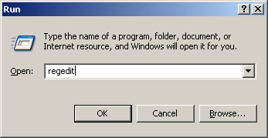
type "regedit", and click "OK".

3. The "Registry Editor" application will appear.
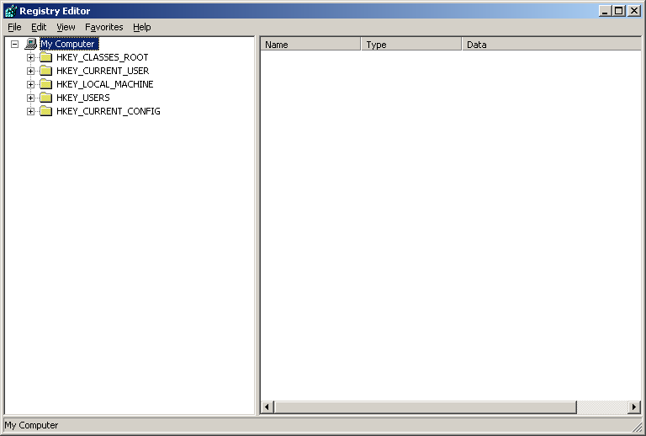

4. In it, choose "Edit > Find ..." .

5. The "Find" window will appear.
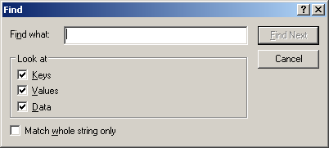

6. In it, enter the name of a machine that you have created a putty session for. In this example, it is "aiximage1".
In the boxes, check only "Keys". Leave the rest unchecked.

Click "Find Next".

7. The find process will come back will come back showing machine name. Above it, you will see folders "Putty", and under it, "Sessions". See example.
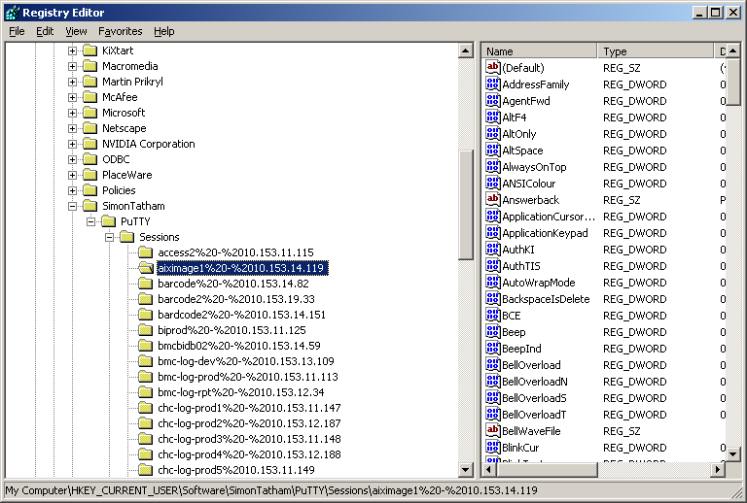

8. Right click on the "Sessions" folder. From the menu, select "Export".
(Please note: you can save individual machine profiles by right clicking on the folder directly to beside the machine name.)
9. The "Export Registry File" window appears.
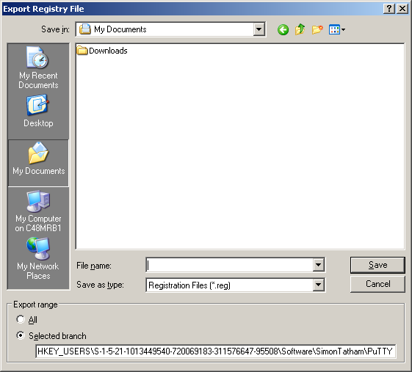
In it, give the file a name in:
"File name:",
and click "Save".
10. Back at the "Registry Editor", select:
File > Exit
.
===
11. Make sure putty is installed on the new system.
12. Copy the file to a new system.
13. On it, select the file, and right click it. From the pop-up menu, select:
Merge
.
14. A warning window will appear.
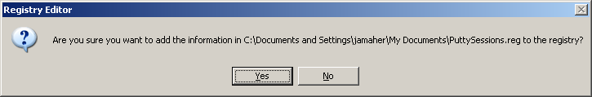
Select "Yes".
15. Select:
Start > Programs > Putty > Putty
16. In the window that appears,
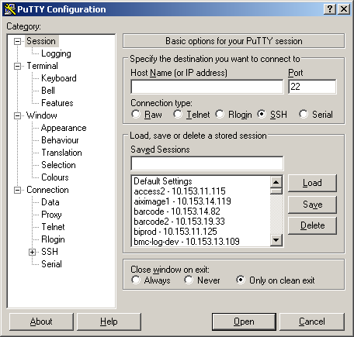
you should now see all the sessions.

