A blade center has a DVD drive that can be assigned to one of the individual blades. Once assigned to that blade, it can be assigned to any of the LPARs that reside on that specific blade. This document goes over how to add it there.

1. Open an IE web browser window, and connect to the blade center gui.

In our example, we are connecting to "https://bc2003.kan".

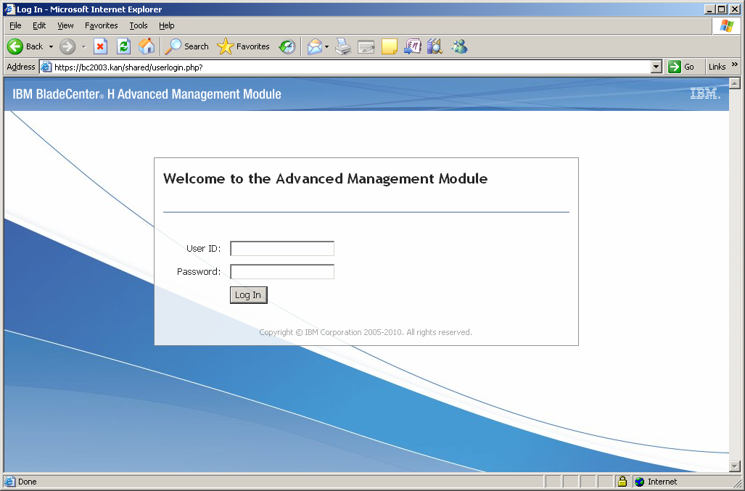

2. Log in as root.

3. This will bring you to a window telling you information about automatic timing out for the session.

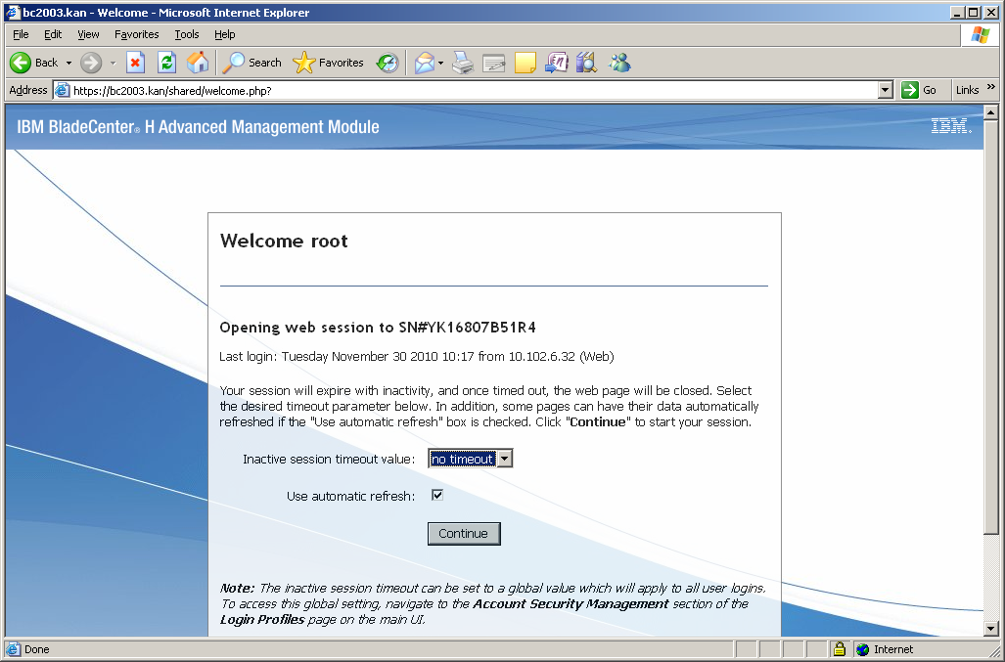

Take the defaults by clicking:

Continue

4. You will be brought to blade center gui.

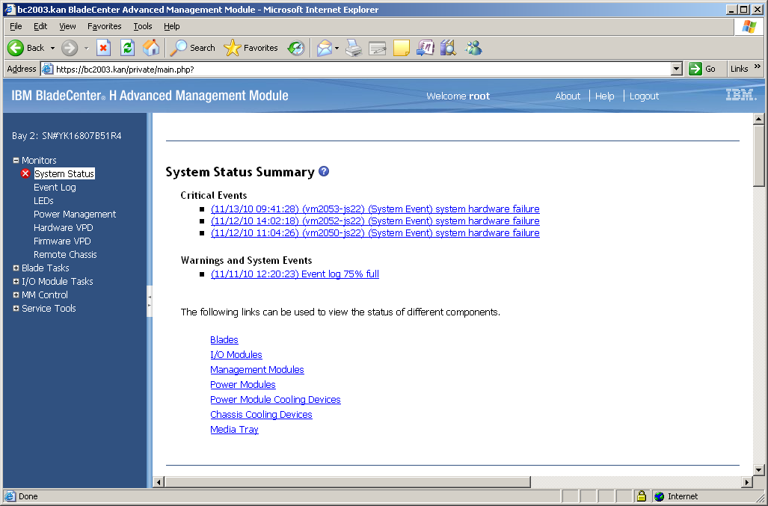

In the left hand pane, click on "-" sign by "Monitor" to shrink it.

Expand:

Blade Tasks

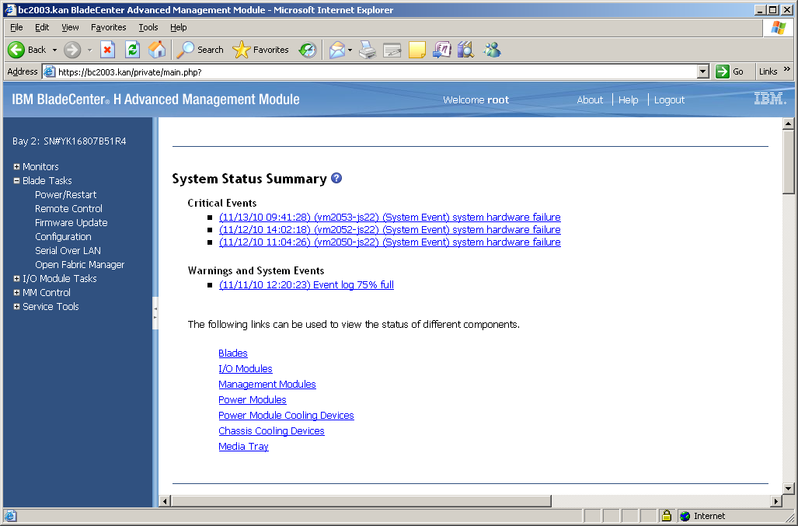

5. Select:

Blade Tasks > Remote Control

You will be brought to the remote control menu.

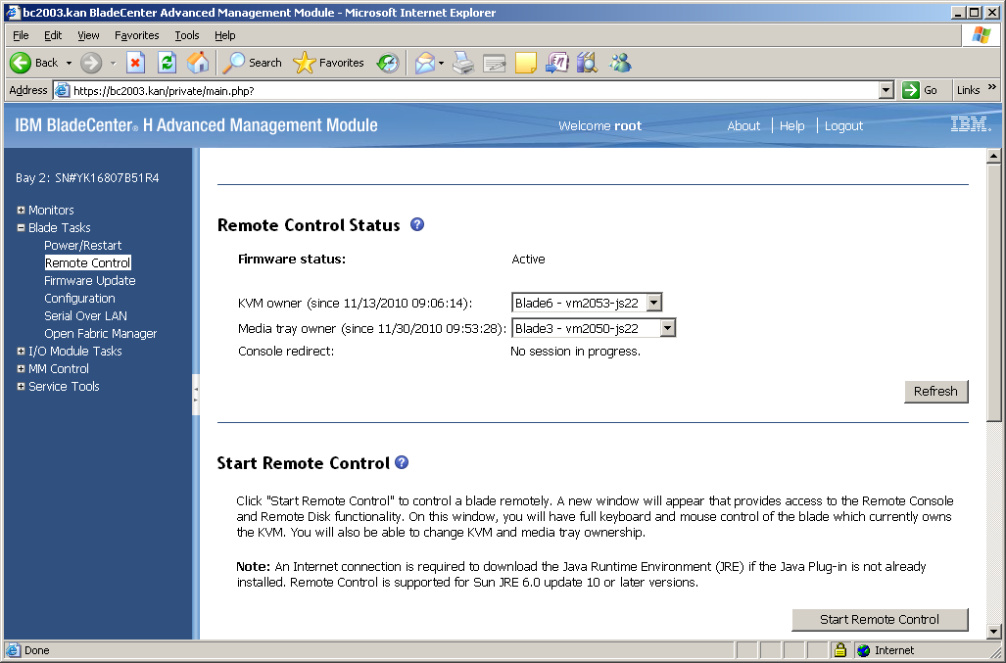

6. In it, in the right hand pane, in the field:

Media tray owner

, select:

The blade that you want to own the DVD player.

In our case it is, "Blade3 - vm2050-js22".

Click:

Refresh

7. In the upper, right hand corner, click:

Logout

8. Open a putty session to the vio server that is on that blade.

9. Become root:

oem_setup_env

10. Make the DVD player known to the vio server by rereading the
system configuration which now has the DVD listing in it.

cfgmgr

The DVD player is now assigned to that particular blade, and known to it. Now, we need to assign it to one of the LPARs on the blade.

11. Open a web browser (IE), and connect to the blade's gui.

In our example, we assigned the DVD player to vm2050. So, we are connecting to:

https://vm2050.kan.ironmountain.com/

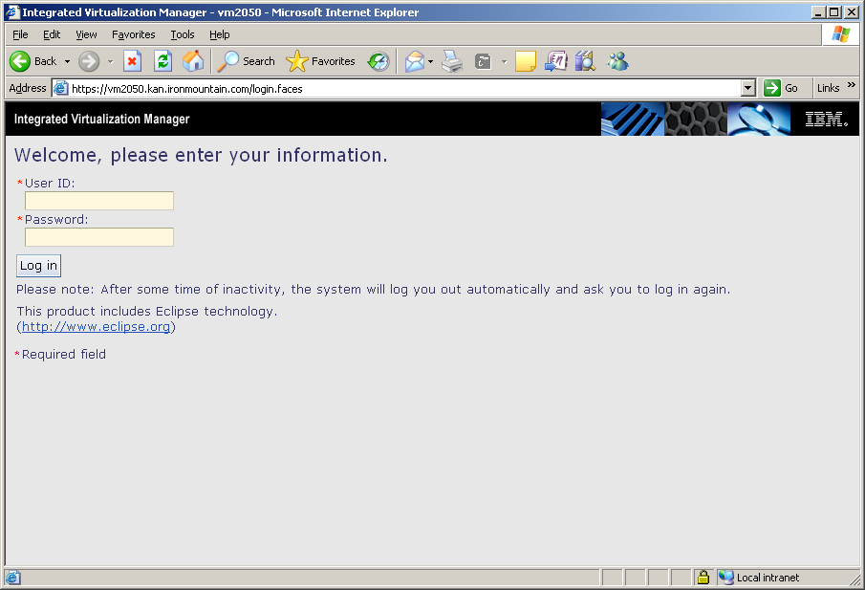

12. At the main screen, log in as:

padmin

The main management screen will appear.

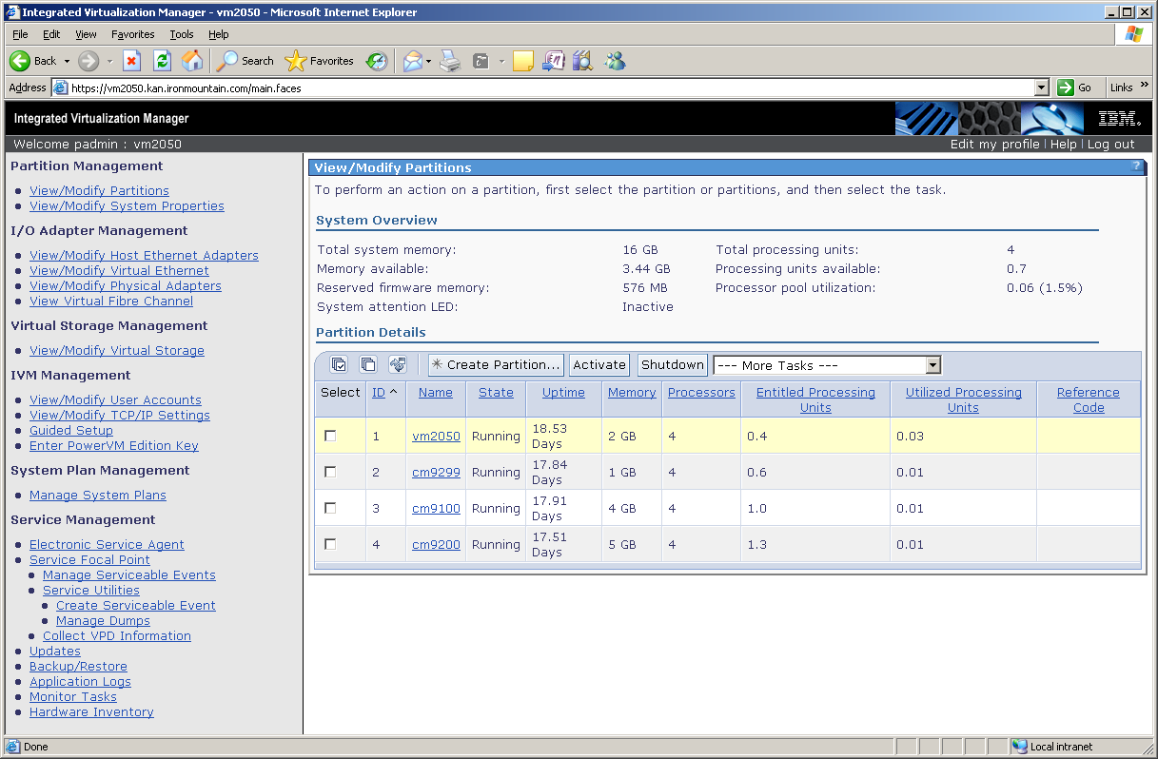

13. In the left hand pane, click on:

View/Modify Physical Adapters

The "View/Modify Physical Adapters" menu will appear.
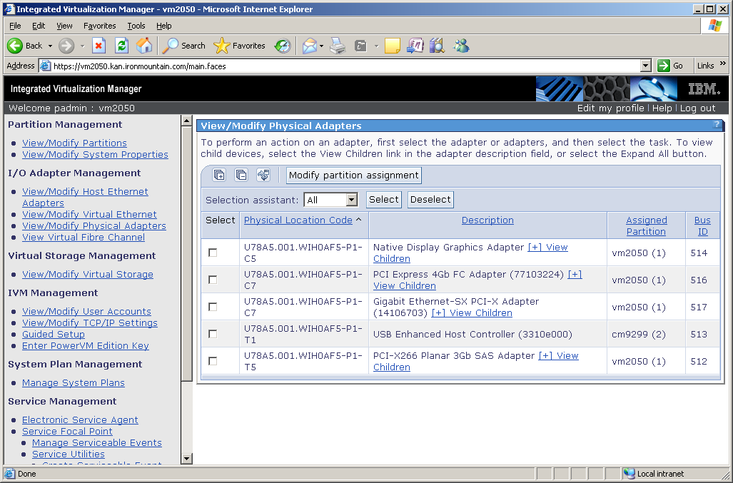

14. In the list in the right hand pane, look for an entry that says "USB Enhanced Host Controller". This is the DVD player, and will most likely have a Bus ID of "513".

Click the box beside it to select it.

Click on the button on the top of the menu called:

Modify partition assignment

The "Modify Physical Adapter Partition Assignment" menu will appear.

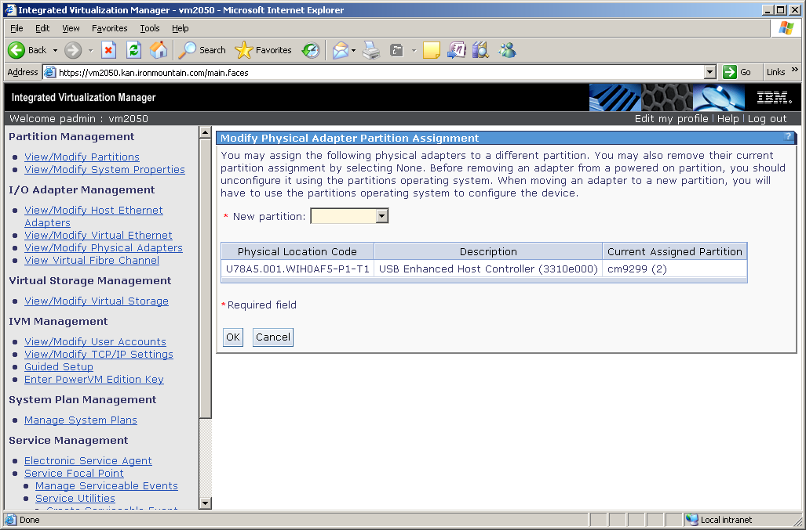

15. From the "New partition" drop down menu, choose:

the LPAR to which you want the DVD player assigned.

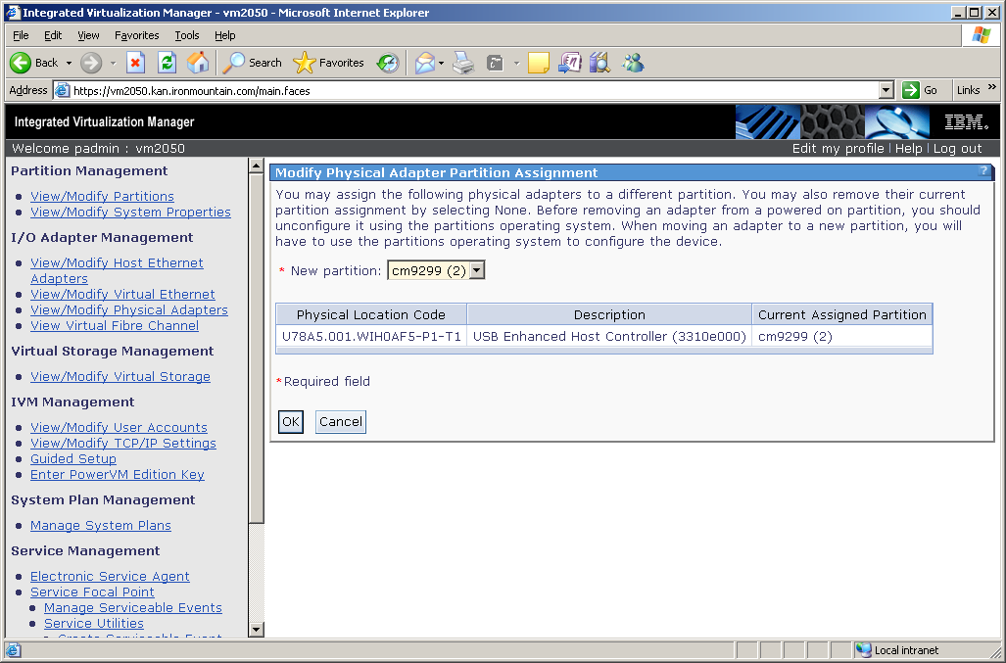

16. Click:

OK

The request will process. (See screen below.)
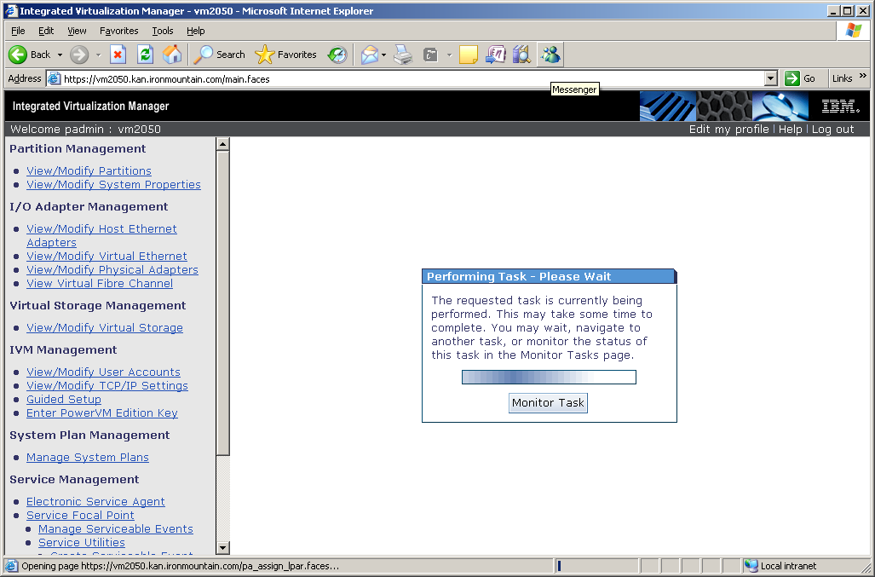

17. Eventually, you will be returned to the "View/Modify Physical Adapters" menu. In it, you will now see that the adapter is assigned to the LPAR.

18. At this point, you can log out of the gui by clicking on the

Log out

link in the top, right hand corner.

19. Log in to the LPAR to which you just assigned the DVD player.

Become root:

sudo su - root
(or)
su - root

20. Read in the new configuration:

cfgmgr

21. At this point, the DVD player will be available to use.

